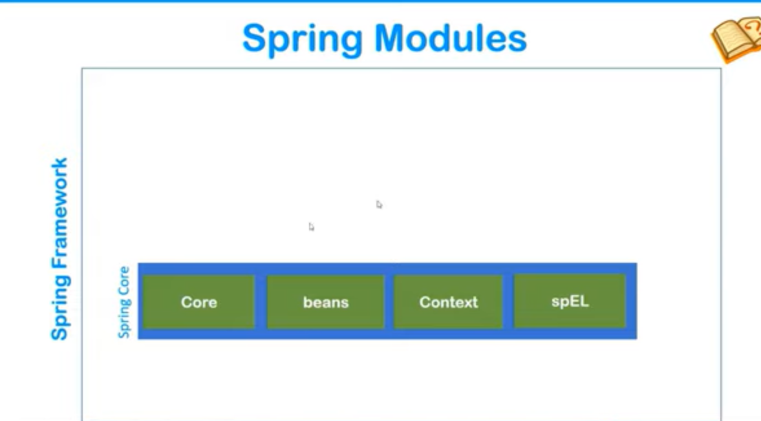

Container is a predefine program which we find within spring framework.

**Responsibility of Spring Container :-**

* It is responsible for creating object.
* It is responsible for holding object into memory.
* Injecting object into another object as required.

